Anti-Bullying Policy

Rationale
Everyone at Black Lane County Primary School has the right to feel welcome, secure and happy. Bullying of any sort prevents this happening and prevents equality of opportunity. Bullying of any kind is unacceptable at Black Lane. It is everyone’s responsibility to prevent it from happening and this policy contains guidelines to support this ethos.

Where bullying does occur, all pupils, staff, parents and governors should feel confident to activate the anti-bullying systems within school to prevent further bullying. It is our aim to help build an anti-bullying ethos in our school.

Definition
Bullying is the use of aggressive behaviour, name-calling or intimidation with the intention of hurting another person. Bullying results in pain and distress to the victim.

Bullying can be short term or continuous over long periods of time.

Types of Bullying
Frequently, bullying behaviours arise from difference or perceived difference: disability, ability, gender, appearance or circumstance can make young people particularly vulnerable to bullying. Able pupils as well as those with learning difficulties may also be affected by this.

Bullying can be:
- Emotional - being unfriendly, excluding, tormenting (e.g. hiding books,
Threatening gestures), threatening behaviour
- Physical - pushing, kicking, hitting, punching or any use of violence
- Racist - racial taunts, graffiti, gestures
- Sexual - unwanted physical contact or sexually abusive comments
- Homophobic - because of, or focussing on the issue of sexuality
- Verbal - name-calling, sarcasm, spreading rumours, teasing
- Cyber - all areas of internet, such as email & internet chat room misuse. Mobile threats by text messaging & calls. Misuse of associated technology e.g. camera and video facilities including those in mobile phones

To a child bullying is:
• Deliberately hurtful
• Repeated
• Difficult to counteract by the victim
• Different from random acts
• Characterised by an ‘imbalance of power’ e.g. a more powerful person or persons intentionally hurting a less powerful person or persons.

Bullying can take place in the classroom, playground, toilets, on the journey to and from school, on residential trips and cyberspace. It can take place during out of school group activities and between families.

Dealing with and preventing bullying
Black Lane fosters a clear understanding that bullying, in any form is unacceptable and not tolerated. This is done by dealing with bullying, as a whole school issue and implementing strategies to prevent bullying:
- The policy is reviewed in accordance with the latest guidance from the Welsh Assembly Government and all staff are aware of procedures to deal with incidents of bullying.
- Personal and Social Education scheme – provides opportunities to discuss bullying in lessons.
- Circle Time – pupils regularly discuss issues surrounding bullying during circle time sessions, building self esteem.
- Playground Buddies – Year 6 pupils support relationships with younger pupils at playtime and provide a ‘buddy’ for pupils to go to if they need to.
- Anti-bullying week – all pupils take part in a range of anti-bullying activities to raise awareness and discuss issues.
- E safety – our e-safety policy outline acceptable use of the Internet and addresses cyber bullying.
- Regular praise of positive and supportive behaviour is used by all staff.
- PCSO – Stuart Reeves visits the school regularly to discuss bullying and internet safety with the pupils.
- SAP – pupils have opportunities to discuss issues around bullying confidentially.
- Emotional wellbeing support programmes to meet the needs of the pupil e.g. Unearthing, Drawing and Talking, Lego Group, ELSA
- Questionnaires: pupils can express feelings about bullying anonymously – these are responded to promptly.

Strategies for Parents:
Parents who are concerned that their child might be being bullied, or who suspect that their child may be the perpetrator of bullying, should contact their child’s class teacher immediately. If they are not satisfied with the response, they should contact the headteacher. If they remain dissatisfied, they should follow the school’s complaints procedure.

Parents have a responsibility to support the school’s anti-bullying policy, actively encouraging their child to be a positive member of the school.

We value the support of parents and carers and believe it is key to the success of our anti bullying strategies. Parents are kept informed:
- Parents evenings
- Anti bullying week
- Leaflets
- The school prospectus
- School website and Class Dojo
- Our ‘Open Door’ Policy

If parents suspect that their child is being bullied they should:
- Talk to the child calmly about the situation
- Listen and reassure the child that coming to you was the right thing to do
- Assure them that bullying is not their fault and that you are there to support them
- Make a note of what the child says
- Find out what the child wants to happen next
- Make an appointment to see the child’s class teacher as soon as possible
- Discuss the next steps with the class teacher and make a note of the action to be taken
- Agree upon a follow up meeting to review/monitor the situation
- If you do not feel the situation is being dealt with successfully contact the headteacher.

If, following discussion, we confirm that a child has been displaying bullying behaviour towards another pupil we will contact the parents to discuss the situation. We will ask parents to support us by:

- Talking to the child and explaining that this behaviour is wrong and how it makes others’ feel.
- Showing the child how to join in with others without bullying.
- Make an appointment to see your child’s teacher as soon as possible – to discuss how we can work together to help the child change behaviours.
- Talking to the child regularly about how things are going at school.
- Giving the child lots of praise and encouragement when they are being kind and considerate to others
- Remembering that the child is not a bully, it is the way they are choosing to behave and that behaviours can be changed. It is often the case that when a child chooses to bully others, they are often seeking help themselves.

Strategies for pupils:
We encourage pupils to tell someone of they are being bullied or if they know that another pupils is being bullied. At no point should they keep it to themselves. Pupils can tell:
- Another pupil
- A Buddy
- Class teacher
- Teaching Assistant
- Lunchtime Supervisor
- Head teacher
- Parents/carers

During PSE lessons, circle time, anti-bullying week, E Safety week and visits from the PCSO pupils are shown ways of dealing with bullying behaviour. They learn ways of resisting peer pressure and are given possible ways of getting out of threatening situations. If pupils are faced with these situations they can:
- Stay calm and act confident
- Tell the person who is bullying you that you do not like the way they are treating you
- Thin of a reason to leave the situation
- Tell someone in school straight away
- Tell your parents straight away
- Remember it’s not your fault and you do not have to put up with it.

The role of governors
The governing body supports the headteacher in all attempts to eliminate bullying from our school. The governing body will not condone any bullying at all in our school, and any incidents of bullying that do occur will be taken very seriously, and dealt with appropriately.

The governing body monitors incidents of bullying that do occur, and reviews the effectiveness of this policy regularly. The governors require the headteacher to keep accurate records of all incidents of bullying, and to report to the governors on request about the effectiveness of school anti-bullying strategies.

A parent who is dissatisfied with the way the school has dealt with a bullying incident can ask the chair of governors to look into the matter – in line with complaints procedures policy.

The role of the teacher and support staff

All the staff in our school take all forms of bullying seriously, and seek to prevent it from taking place. staff should:
- Be vigilant for signs of bullying.
- Listen carefully to both sides to confirm that it is bullying.
- All incidents that occur at break times/lunchtimes should be reported verbally to the class teacher by the adult who has been involved with the incident.
- Always take reports of bullying seriously and investigate them
- Do not make premature assumptions
- If the incident is not too serious – adopt a problem-solving approach which moves the child on from justifying themselves.

If a child has been involved in a confirmed bullying incident the following procedures will be followed:
- A meeting will be held with both the victim and the child who has bullied. Both parties will be given a chance to share their feelings. This will be carried out by the class teacher or adult in charge of the class.
- The incident will be recorded and the situation monitored closely.
- The child who has bullied will discuss the behaviour and the impact on others feelings, identifying how they could change their behaviour. The child will be issued with a consequence in line with the behaviour policy.
- Class teachers will follow up and check that bullying has not resumed.
- If the child continues to bully the victim, the situation will be logged officially.
- Older pupils may be asked to write a report of the incident themselves and witnesses may also be asked to write an account of what happened.
- Using Restorative Practice techniques time is spent talking to the child who has bullied: explaining why his/her action was wrong, and that child is encouraged to change his/her behaviour in future.
- The child’s parents will be invited into school to discuss the matter and next steps.
- The child may be withdrawn from break and lunchtimes for a fixed period of time
- Withdrawal from group/class if necessary
- Support from outside agencies e.g. counselling, behaviour support
- If all of the above steps fail to help the child to change their behaviour then it may be necessary to exclude.

All proven incidences of bullying should be reported immediately to the headteacher.

The role of the headteacher

It is the responsibility of the headteacher to implement the school anti-bullying strategy, and to ensure that all staff (both teaching and non-teaching) are aware of the school policy, and know how to identify and deal with incidents of bullying. The headteacher reports to the governing body about the effectiveness of the anti-bullying policy on request.

The headteacher ensures that all children know that bullying is wrong, and that it is unacceptable behaviour in this school. The headteacher draws the attention of children to this fact at suitable moments. For example, if an incident occurs, the headteacher may decide to use an assembly as the forum in which to discuss with other children why this behaviour was wrong, and why a pupil is being punished.

The headteacher ensures that all staff, including lunchtime staff, receive sufficient training to be equipped to identify and deal with all incidents of bullying.

The headteacher sets the school climate of mutual support and praise for success, so making bullying less likely. When children feel they are important and belong to a friendly and welcoming school, bullying is far less likely to be part of their behaviour.

Equal Opportunities

Equality of opportunity means that all children have the opportunity to achieve the best possible development, regardless of their gender, ability, ethnicity, circumstances or age. Some vulnerable children may have been particularly disadvantaged in their access to important opportunities and their health and educational needs will require particular attention in order to optimise their current welfare as well as their long-term outcomes in young adulthood.

Monitoring and review

This policy is monitored on a day-to-day basis by the headteacher, who reports to governors on request about the effectiveness of the policy.

This anti-bullying policy is the governors’ responsibility, and they review its effectiveness annually. They will do this by examining the school’s anti-bullying logbook, where incidents of bullying are recorded, and by discussion with the headteacher. Governors will analyse information for patterns of people, places or groups. They will look out in particular for racist bullying, or bullying directed at children with disabilities or special educational needs.

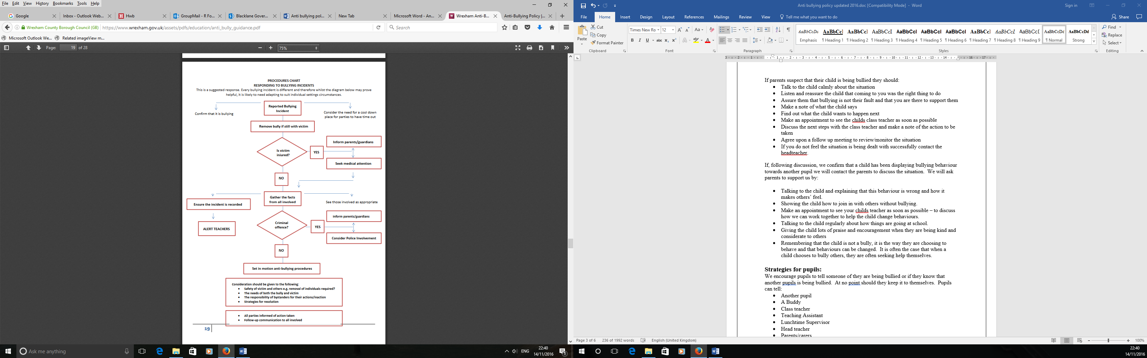
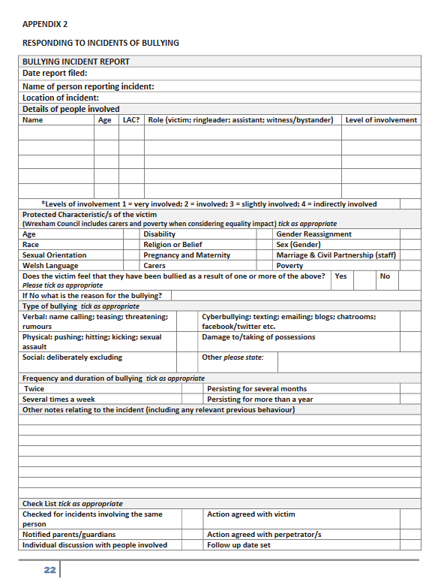
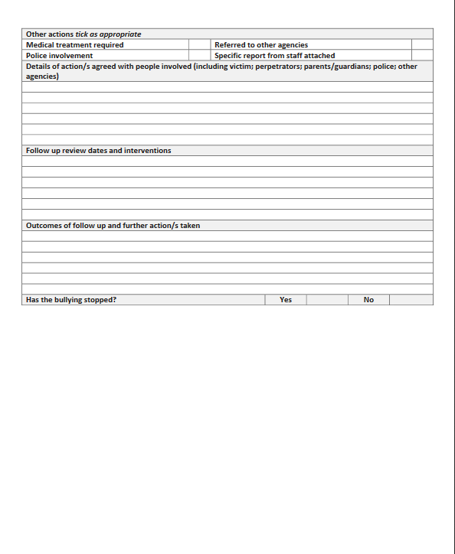

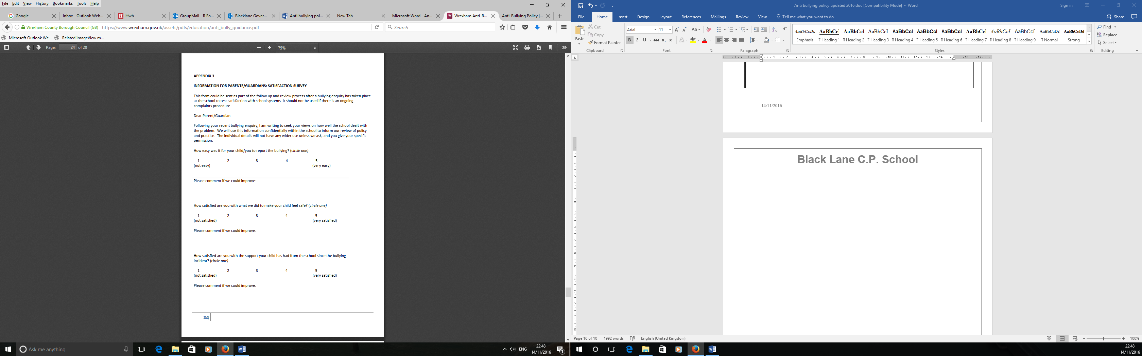

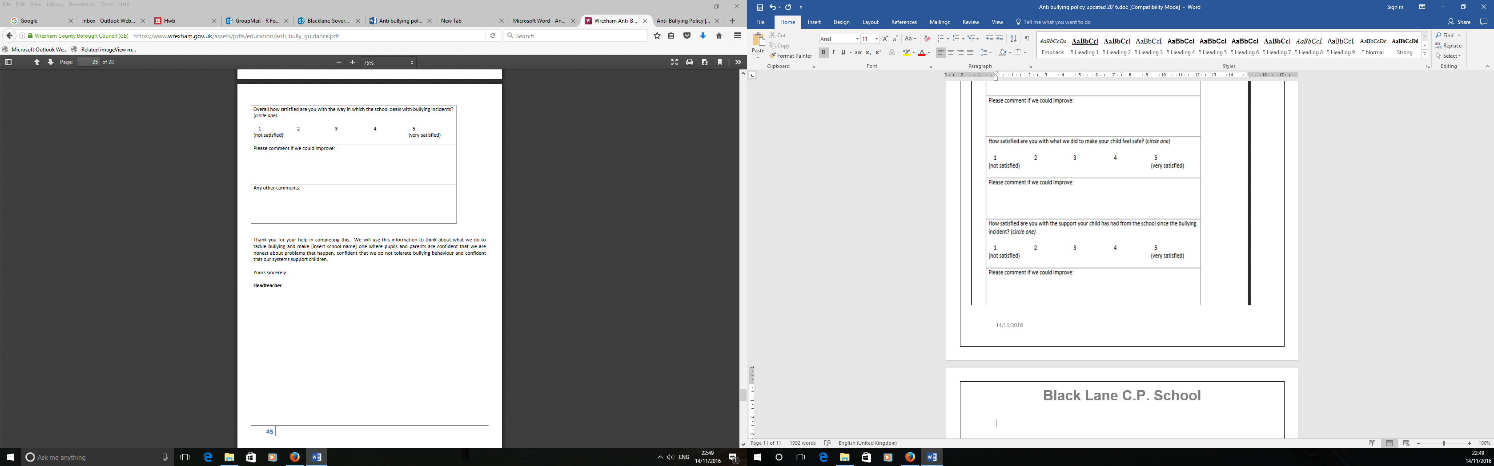

Mrs R Fox
Headteacher

