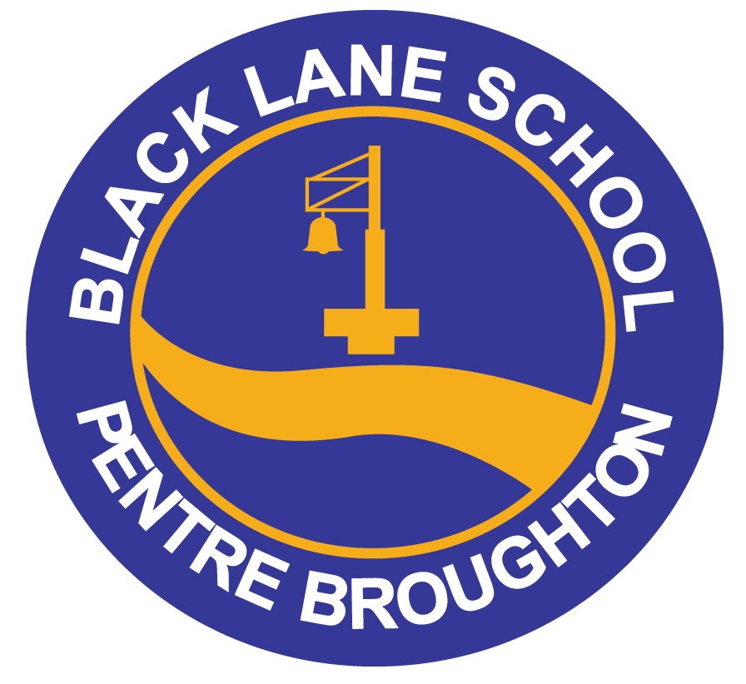
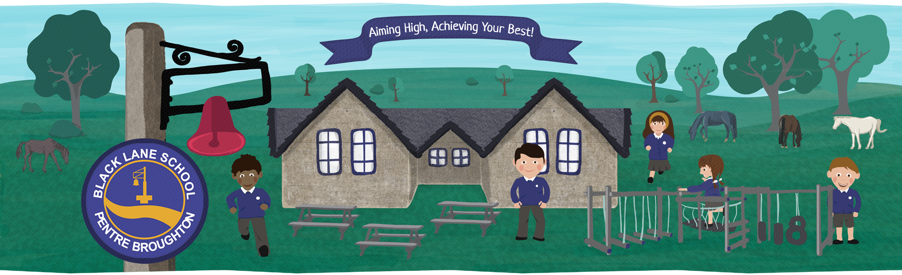
Information Booklet

Aiming High, Achieving your Best!
Headteacher: Mrs B Fox
Deputy Headteacher: Mrs C Peters
www.blacklaneschool.co.uk

Cadair Idris is a year 3 class and currently consists of 20 pupils
Class teacher: Mr A Davies

The Curriculum for Wales
The schools follows the Curriculum for Wales and endeavours to provide an education that is relevant to the experiences of our pupils and the world around them.
It is a journey – it will build their ability to learn new skills and apply their subject knowledge more positively and creatively with real life meaning and experiences.

The Four Purposes
The ‘Four Purposes’ are at the heart of the Curriculum for Wales. These have guided the whole design of the curriculum and set out the aspirations for all children and young people in Wales. They are a starting point for all decisions on the content and experiences developed as part of the curriculum.
The purpose of the curriculum is to support learners to be:
- Ambitious, capable learners ready to learn throughout their lives
- Enterprising, creative contributors, ready to play a full part in life and work
- Healthy, confident individuals, ready to lead fulfilling lives as valued members of society
- Ethical, informed citizens of Wales and the world

Areas of Learning Experiences (AoLEs)
The curriculum is about connecting learning and ensuring that learning focuses on what matters for learners now and in the future. As well as learning the three cross-curricular responsibilities: literacy, numeracy and digital skills, there will be six areas of learning and experience. Everything children learn will connect to these areas:
- Health and Wellbeing
- Language, Literacy and Communication
- Mathematics and Numeracy
- Expressive Arts
- Humanities
- Science and Technology

The curriculum will also cover:
- Human rights and the United Nations
Conventions on the Rights of the Child
- Diversity and respecting differences
- Experiences and skills for careers and the workplace
- Local, national and international aspects of all learning
- Relationships and Sexuality Education (RSE)



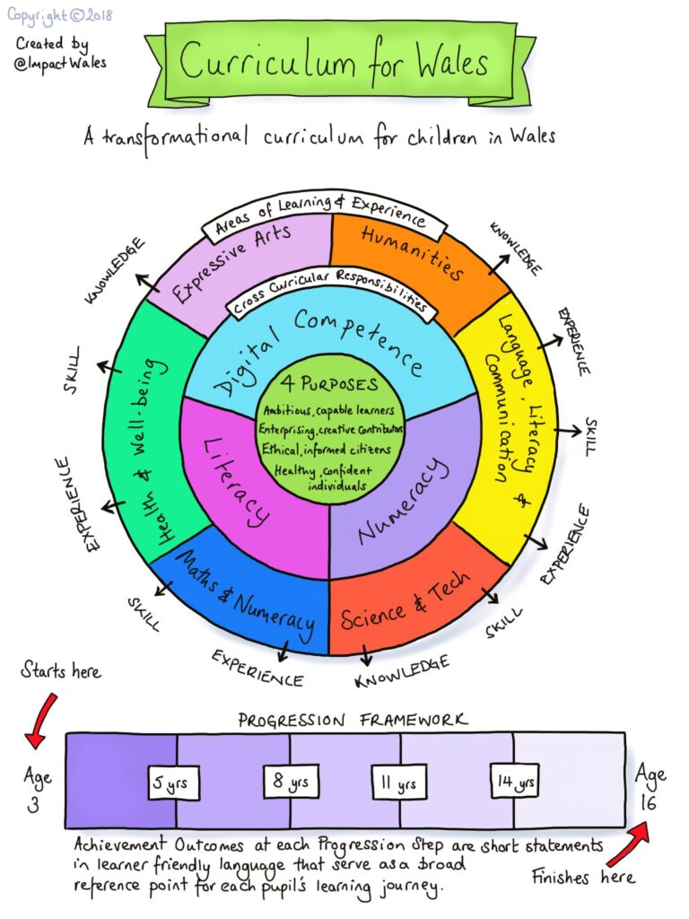
Water and Snack
Children are encouraged to drink water throughout the day. Please provide a labelled water bottle. Juice is not allowed in class.

Children are provided a healthy school snack at a cost of £1.00 per week, which consists of a wide range of fruit and vegetables. This is payable through ParentPay.

The School Day
8:45am – Open doors
8:55am – School Starts
10:45 – 11:00am – Break time
11:55am – 12:55pm – Lunchtime
3:10pm - Home time

Planning, Preparation and Assessment (PPA) time
Mr Davies’ PPA time will be covered by Miss Matthias every Monday afternoon.

Medical/Illness
If your child is absent from school then please contact the school office by 9:30am. If we do not receive notification of absence then we will call you to find out where your child is.

School Dinners
All primary school children in Wales get a free school meal.
Parents needs to book meals in advance – before 8:00am each day. Meals can be booked for 3 weeks in advance.
https://www.parentpay.com/schools/
Weekly Home Learning
Home Learning has a positive impact on children’s learning. We want home learning to be an integral part of learning that is going on in school. We encourage parents/carers to support with home learning throughout the week:
Reading: The recommended amount of reading is 10 minutes per day. Please listen to your child reading and make a comment in the reading diary. A new book will be given each time it is returned and signed.
TT Rockstars: We recommend that children spend at least 5 minutes every day on TT Rockstars. This is a fun, interactive platform that helps pupils improve their speed and accuracy with multiplication and division facts through short, engaging games.

PE
PE will be on Wednesday and Thursday each week.
Cadair Idris will go swimming in the Summer term (April-July) every Thursday morning. We ask for £2.00 donation towards the bus.
PE Kit: White t shirt, school jumper or cardigan, black shorts/leggings and trainers. Jogging bottoms and jackets may be required in colder weather.
No jewellery is to be worn and long hair must be tied up. Please label all items of clothing.

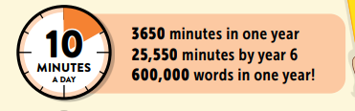

Curriculum Details
This year we will be delivering the curriculum through the following topics:
Term | Topic and Focus
Autumn Term | Local Area – Brymbo Heritage
Spring Term | TBC
Summer Term | TBC
*Children input into planning throughout the year, so topics and learning activities may change depending on pupil voice and interest.
Residential Trips
Children in Years 3-6 will get the opportunity to attend residential trips. Residential trips are extremely beneficial to pupils and develop important life skills. Pupils will participate in team activities building relationships with peers; develop self-esteem, confidence and independence whilst developing knowledge and understanding of the world around them. Our residential trips include:
• Glan Llyn /Pentrellyncwmer(1 night, 2 days) – Year 3&4
• Cardiff /Nant BH (2 nights, 3 days) – Year 5&6
These will be on a two year rolling programme

Useful Websites and Links
https://hwb.gov.wales/
Hwb website where children can access emails, resources, games and complete home learning. Each child has their own individual login and password. The j2 section is excellent!
www.classdojo.com
We communicate school and class information through Class Dojo. Please make sure that you sign up to keep updated. You can also communicate with your class teacher through here.
A Guide to the New Curriculum for Wales
A new curriculum for Wales – A Parents Information Guide
https://www.oxfordowl.co.uk/
This gives you access to free resources to help your child learn. You can access free e-books to support with reading at home.
https://www.borrowbox.com/
A library of free online books
https://home.oxfordowl.co.uk/reading/reading-schemes-oxford-levels/read-write-inc-phonics-guide/
We follow Read Write Inc. Phonics to teach children the sounds, the letters that represent them and how to form the letters when writing. This resource gives you access to parent tutorials to learn about how to support your child as they learn.
Mathematics and Numeracy
We encourage children to practise mental maths every day. We encourage 5 minutes on TT Rockstars everyday as this tracks progress. However, there are other websites that are useful:
- https://play.ttrockstars.com/ - Pupils have individual logins and can track their progress
- https://www.j2e.com/j2blast - this can be set at different levels
- https://www.topmarks.co.uk/ - lots of number games to practise number bonds and multiplications.
- The favourite is Hit the Button: https://www.topmarks.co.uk/maths-games/hit-the-button

