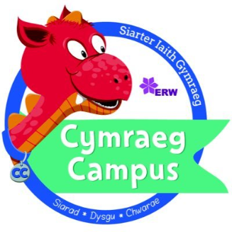
Criw Cymraeg

Black Lane is looking for pupils wishing to promote incidental Welsh and a Welsh ethos throughout our school.
Job Description:
We are looking for 2 reliable pupils – 1 girl and 1 boy from each class from years 2-6 to be part of a team to help improve our school for everyone. The role will involve:
- Listening to the views of others
- Working as a team
- Decide and introduce a ‘Phrase of the week’ in Welsh and teach this phrase to others.
- Carry out and lead a weekly Criw Cymraeg Assembly.
- Make Welsh fun by holding competitions for pupils to enter.
- Creating an enthusiasm for speaking Welsh within our school.
- Improve standards of Welsh throughout our school.
Qualities:
We are looking for pupils who:
- Have an enthusiasm for speaking Welsh.
- Are reliable, hardworking and friendly
- Like helping others
- Are good listeners and good speakers
- Are organised
- Want to make our school a better place for everyone
If you are interested in applying then please outline why you think you would be a good at being in the Criw Cymraeg and return to Miss Lloyd by Friday 29th September 2023.

Criw Cymraeg

I would like to apply to be part of the Criw Cymraeg for the year 2023-2024
Name: ___________________ Year group: ____ Class: ______________

Explain why you would like to apply for a role in the Criw Cymraeg, please include why you think Welsh is so important.

_______________________________________________________________________________________________________________________________________________________________________________________________________________________________________________________________________________________________________________________________________________________________________________________________________________________________________________________________________________________________________________________________________________________________________________________________________________________________________________________________________________________________________________________________________________________________________________________________________________________________________________________________________________________________________________________________________________________________________________________________________________________________________________________________________________________________________________________________________________________________________________________________________________________________________________________________________________________________________________________________________________________________________________________________________________________________________________________________________________________________________________________________________________________________________________________________________________________________________________________________________________

Signed: ________________________ Date: ______________________

